**INHA UNIVERSITY TASHKENT**

**DEPARTMENT OF CSE & ICE**

**SPRING SEMESTER 2020 CAPSTONE DESIGN TEAM REPORT**



**Team name: MasterMinds**

Ochilov Khumoyun U1710188

Kholid Khoshimov U1710190

Farkhadov Khojiakbar U1710207

Tokhirjon Khamdamov U1710217

Mannonov Temur U1710257 *

**Introduction**

This report provides information regarding the brainstorming the sensor mission challenge assignment of an autonomous car using Raspberry Pi. Also, some information will be given about team discussions, what every team member did, and the conclusion for this assignment.

**Brainstorming**

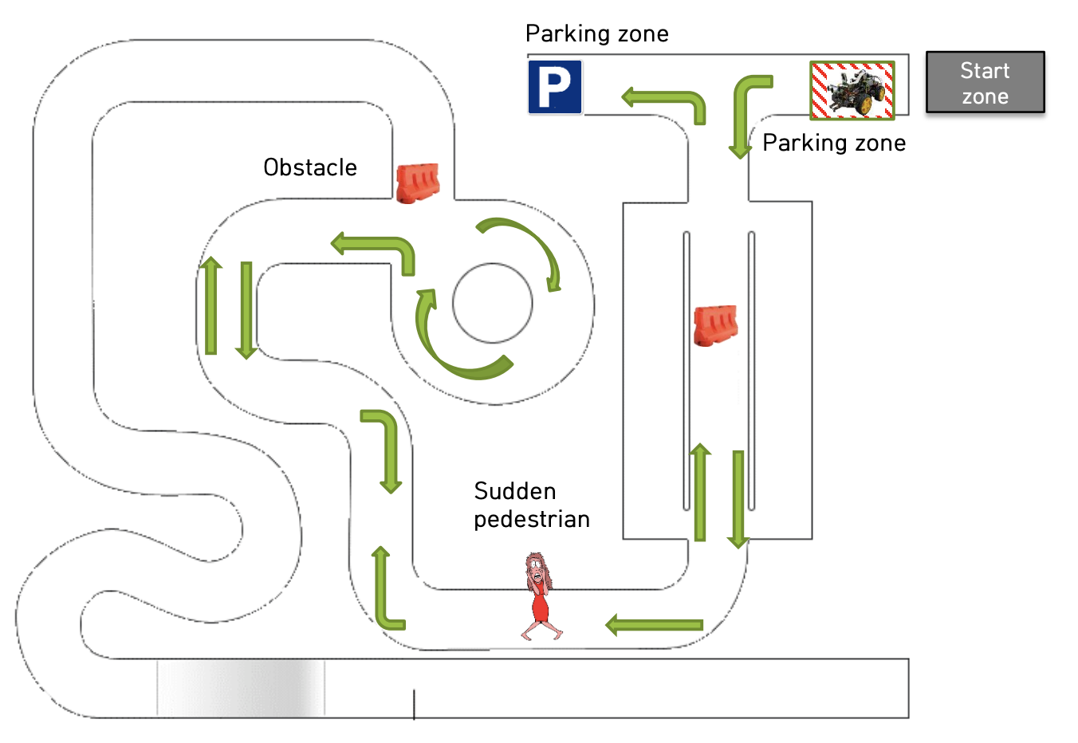

**Candidate Objects**

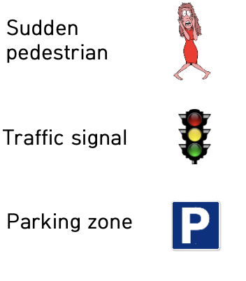        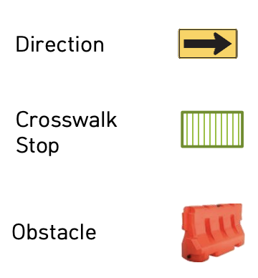

Initially, in our project, we added to our code obstacle detecting function in order to stop before walls, we took into account several moments that belong to accidents. Each of the meters played a fundamental role in our code.

Several issues and discussions that we had faced:

1. Actually, when the car started to race it will turn left when it detects the end of the line with the line tracer sensors.
2. While it goes forward, once ultrasonic sensor or IR sensors detect the obstacle car will bypass the object from the left side of it.
3. Then it goes along the line by detecting yellow lines with IR line tracer sensors. When it detects a sudden pedestrian with the Ultrasonic sensor or IR Sensors, the car tries to bypass it if it detects a line while bypassing the pedestrian it will stop and wait until the pedestrian leaves the way. Once the pedestrian leaves the way car continues to go along the line by detecting yellow line with IR line tracer sensors.
4. After a car passing cycleway, it will encounter an obstacle. When it detects the obstacle it will turn left and goes forward. Then it continues to along the line.
5. When detects the obstacle again it will bypass the obstacle from the left side of it. Then it goes forward, when it detects the line it will turn left and go forward then stop at the parking zone.

The above issues that happened belonged to each other. We all together fixed every problem and the direction of movements, speed control was checked and corrected. One of the great thing we got is that detecting correct objects on the road correctly and do the action.

As the conclusion of brainstorming, the step by step process of making whole project show clearly that appeared issues during the project gave us new ideas in order to complete whole project in a perfect style with researching the needed materials. We implemented various functions for controlling the car such as going forward, going backward, going left, going right, smooth right, and smooth left. Moreover, we took into account candidate objects such as obstacles, sudden pedestrian. We combined all ideas and analyzed the necessary delay time for going right, going left functions.

**Main**

**Role of team members:**

|  |  |  |
| --- | --- | --- |
| Team name | MasterMinds | Date: 4 May 2021 |
| Role | Name | Main Responsibility |
| Team leader | Temur Mannonov | As a spokesperson for the team, convene and preside the meeting |
| Recorder | Khojiakbar Farkhadov | Summarize and record group mission reports, and give summarized documentation to all group individuals with the subject of the other assembly. |
| Report creator | Humoyun Ochilov | Organize conclusions of group individuals and make different reports and introductions. |
| Surveyor | Tokhirjon Khamdamov | Create questionnaire materials, perform questionnaires, and share research findings with team members if you need a questionnaire. |
| Data collector | Kholid Khoshimov | Collect and arrange team-related online and offline content, and distribute them to team members two days before the next meeting. |

|  |  |  |  |  |
| --- | --- | --- | --- | --- |
| **Team minutes** | | | | |
| Team Name | MasterMinds | Leader | Temur Mannonov |  |
| Team purpose | Brainstorming for mission clear | | | |
| Team Operating period | May 1, 2021  14:00-17:30 | | | |
| Team members | ID | Name | Email | Phone number |
| U1710257 | Temur Mannnonov | [t.mannonov@student.inha.uz](mailto:t.mannonov@student.inha.uz) | +998903599940 |
| U1710207 | Khojiakbar Farkhadov | k.farkhadov@student.inha.uz | +998909876297 |
| U1710188 | Humoyun Ochilov | h.ochilov2@student.inha.uz | +998998762404 |
| U1710217 | Tokhirjon Khamdamov | t.khamdamov@student.inha.uz | +998909985890 |
| U1710190 | Kholid Khoshimov | k.khoshimov@student.inha.uz | +998911550022 |